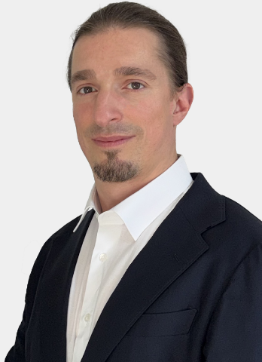
Sebastien Lambot
IT Manager – Transformation & Infrastructure
Email : sebastien@it-tude.be
Website: https://www.lambot.info
Mobile : +32 477 315699
Nationality : Belgian
Born : 26 December 1984 (Uccle)
Languages: French (native), English (professional), Dutch (basic)
Strengths:
Leadership, Communication, Analytical Thinking, Performance-driven

Experienced IT Manager with over 15 years in technology strategy, project delivery, and management of critical infrastructure across industrial, pharmaceutical, and financial sectors.
Recognized for aligning IT systems with business goals, driving team engagement, and leading digital transformation initiatives in demanding environments.
· · · · · · · · · · · · · · · · · · · · · ·
NLMK – ICD Europe System Manager (2021 – Present | Europe)
- Leading multi-site industrial IT projects in Europe: infrastructure strategy, security, and operational reliability
- Cross-functional coordination with business teams, automation engineers, and maintenance departments
Takeda – IT Infrastructure Engineer (2016 – 2021 | Brussels)
- IT lead for a GMP-certified pharmaceutical manufacturing site; responsible for 400+ servers
- Technical advisor for site expansion projects and regulatory audits
IBM – IT Architect / Senior System Engineer (2012 – 2016 | Brussels)
- Head of IT operations for Solvay: data center migration, system standardization, disaster recovery
- Team management, technical training, and continuity simulations
Euroclear – System Engineer (2011 – 2012 | Braine-l’Alleud)
- Guidance of technical projects from design to production in a secure banking environment
BNP Paribas Fortis – International IT Project Leader (2008 – 2010 | Europe)
- Managed high-impact international IT programs (mergers, new branches, migrations)
- Acted as key liaison between local executives and technical teams in 15 EU countries
Hermes Engineering – System Engineer (2007 – 2008 | Nivelles)
- Completed an intensive graduate training program in emerging technologies (BI, development, databases, virtualization)
· · · · · · · · · · · · · · · · · · · · · ·
Education and certifications:
- MSc in Industrial IT Engineering – ECAM
- Master's in Management – Louvain School of Management
- ITIL v3 | PRINCE2 | CISSP | CEH | CCNA | Azure | VMWare

